Mutchumari Chandrasekhar Reddy-AP25110010976

1. Write a program to sort the array elements using Merge Sort Technique.
Program:
#include <stdio.h>
void merge(int a[], int low, int mid, int high)
{
int i = low, j = mid + 1, k = 0;
int temp[100];
while (i <= mid && j <= high)
{
if (a[i] < a[j])
temp[k++] = a[i++];
else
temp[k++] = a[j++];
}
while (i <= mid)
temp[k++] = a[i++];
while (j <= high)
temp[k++] = a[j++];
for (i = low, k = 0; i <= high; i++, k++)
a[i] = temp[k];
}
void mergeSort(int a[], int low, int high)
{
if (low < high) {
int mid = (low + high) / 2;
mergeSort(a, low, mid);
mergeSort(a, mid + 1, high);
merge(a, low, mid, high);
}
}
int main()
{
int a[100], n, i;
printf("Enter number of elements: ");
scanf("%d", &n);
printf("Enter elements:\n");
for (i = 0; i < n; i++)
scanf("%d", &a[i]);
mergeSort(a, 0, n - 1);
printf("Sorted array:\n");
for (i = 0; i < n; i++)
printf("%d ", a[i]);
return 0;
}
Termial Process:
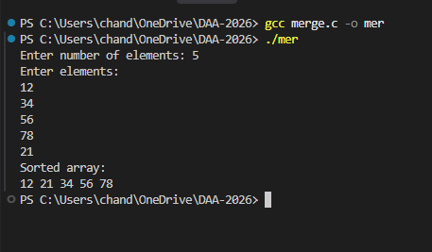

2. Write a program to sort the array elements using Bucket Sort Technique.
Program:
#include <stdio.h>
void bucketSort(int a[], int n)
{
int bucket[100] = {0};
int i, j = 0;
for (i = 0; i < n; i++)
bucket[a[i]]++;
for (i = 0; i < 100; i++)
{
while (bucket[i] > 0)
{
a[j++] = i;
bucket[i]--;
}
}
}

int main()
{
int a[100], n, i;
printf("Enter number of elements: ");
scanf("%d", &n);
printf("Enter elements (0-99):\n");
for (i = 0; i < n; i++)
scanf("%d", &a[i]);
bucketSort(a, n);
printf("Sorted array:\n");
for (i = 0; i < n; i++)
printf("%d ", a[i]);
return 0;
}
Terminal Process:
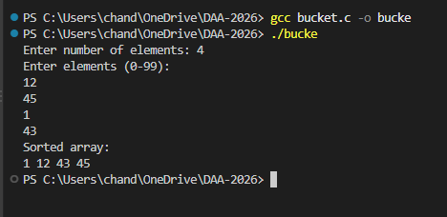
3. Write a program to sort the array elements using Quick Sort Technique.
Program:

#include <stdio.h>
void swap(int *x, int *y) {
int temp = *x;
*x = *y;
*y = temp;
}
int partition(int a[], int low, int high) {
int pivot = a[high];
int i = low - 1;
int j;
for (j = low; j < high; j++)
{
if (a[j] < pivot)
{
i++;
swap(&a[i], &a[j]);
}
}
swap(&a[i + 1], &a[high]);
return i + 1;
}
void quickSort(int a[], int low, int high)
{ if (low < high){
int pi = partition(a, low, high);
quickSort(a, low, pi - 1);
quickSort(a, pi + 1, high);
}
}
int main() { int a[100], n, i;
printf("Enter number of elements: ");
scanf("%d", &n);
printf("Enter elements:\n");
for (i = 0; i < n; i++)
scanf("%d", &a[i]);
quickSort(a, 0, n - 1);
printf("Sorted array:\n");
for (i = 0; i < n; i++)
printf("%d ", a[i]);
return 0;
}
Terminal Process:
